**Project Design Phase-I**

**Solution Architecture**

|  |  |
| --- | --- |
| **Date** | 3 November 2022 |
| **Team ID** | PNT2022TMID10497 |
| **Project Name** | Project - Industry-specific intelligent fire management system |
| **Maximum Marks** | 4 Marks |

**Solution Architecture:**

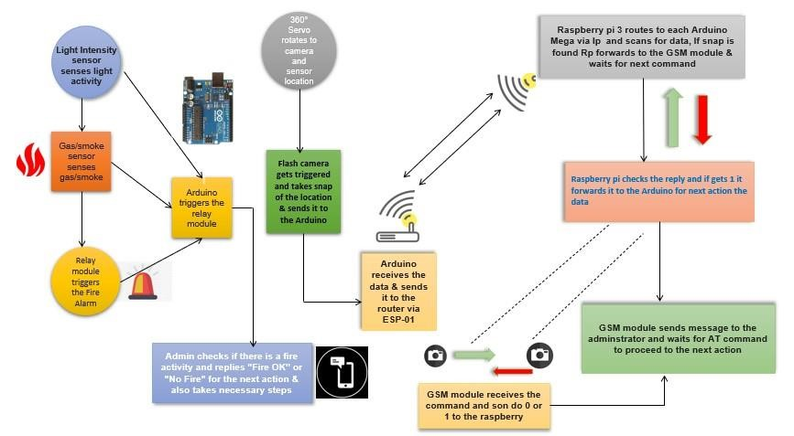

*Architecture and Fire management sample application*